Lab Exercise 20
Creating a Pipeline Script

Name-Manish kumar
Batch-2(DevOps)
SAP ID- 500119723

Objective: To create a pipeline script for automating build processes in Jenkins
Tools required: Jenkins
Prerequisites: None

Steps to be followed:
- Log in to the Jenkins CI tool and create a pipeline script

Step 1: Log in to the Jenkins Cl tool and create a pipeline script

  - Open the browser, go to the Jenkins Dashboard by typing localhost:8080 in your browser, provide the credentials, and click the Sign in button

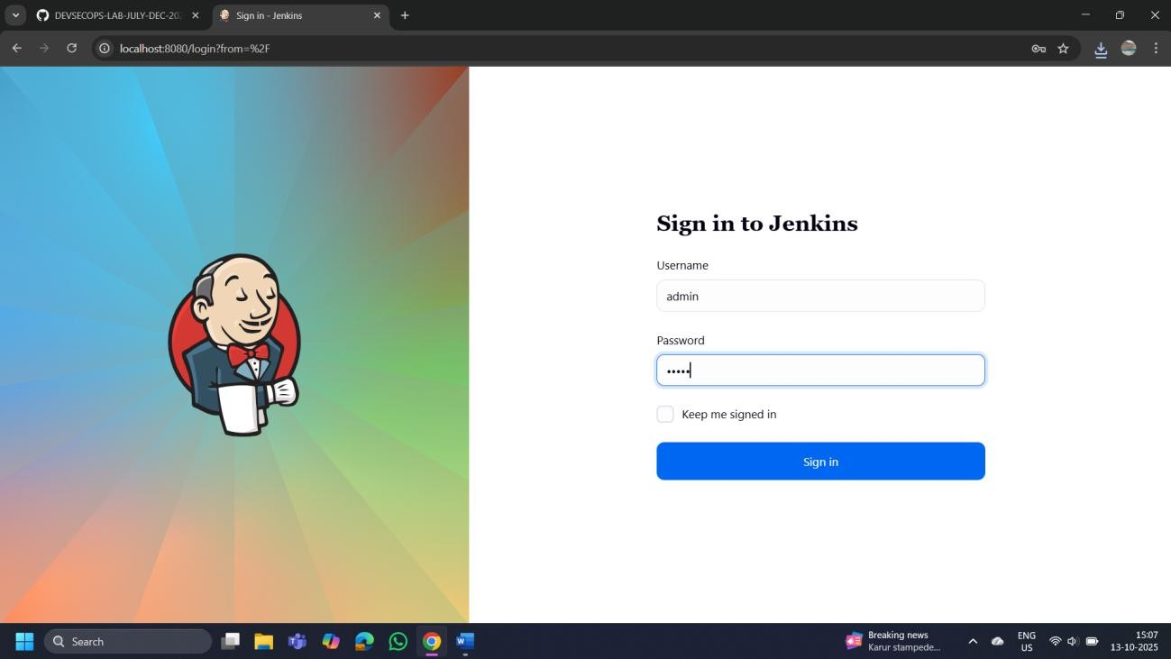

  - Click on the New Item option as shown in the screenshot below:

  - Enter a desired name for the project, select Pipeline, and then click on OK as shown in the screenshot below:

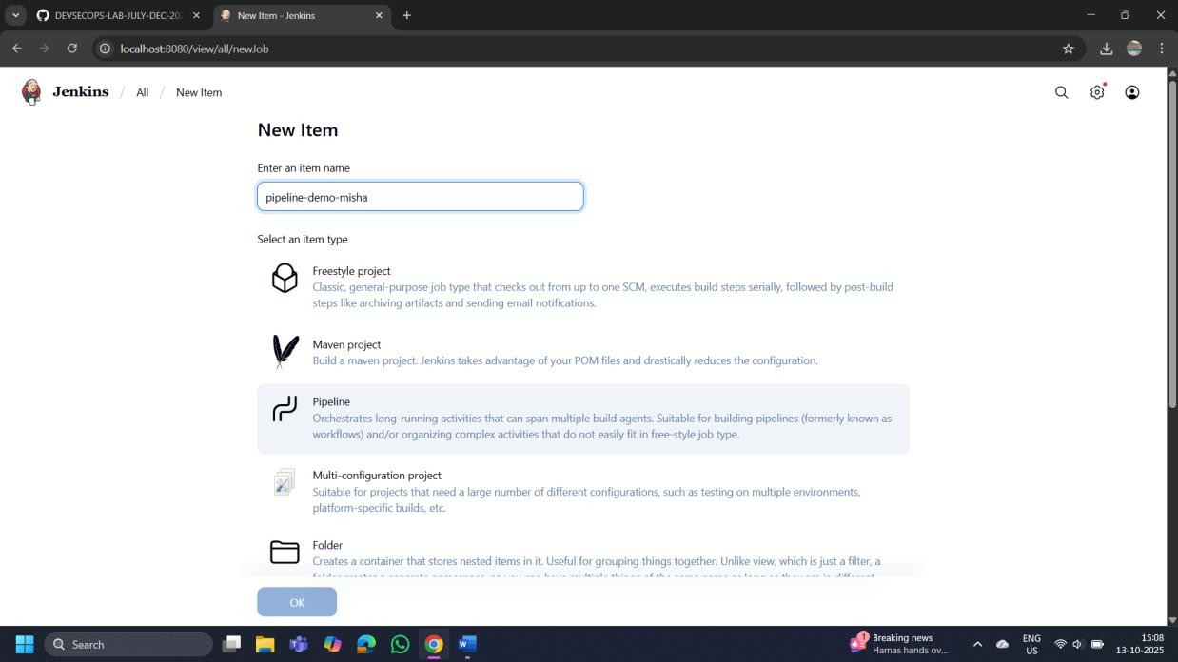

  - Click on Pipeline as shown in the screenshot below:

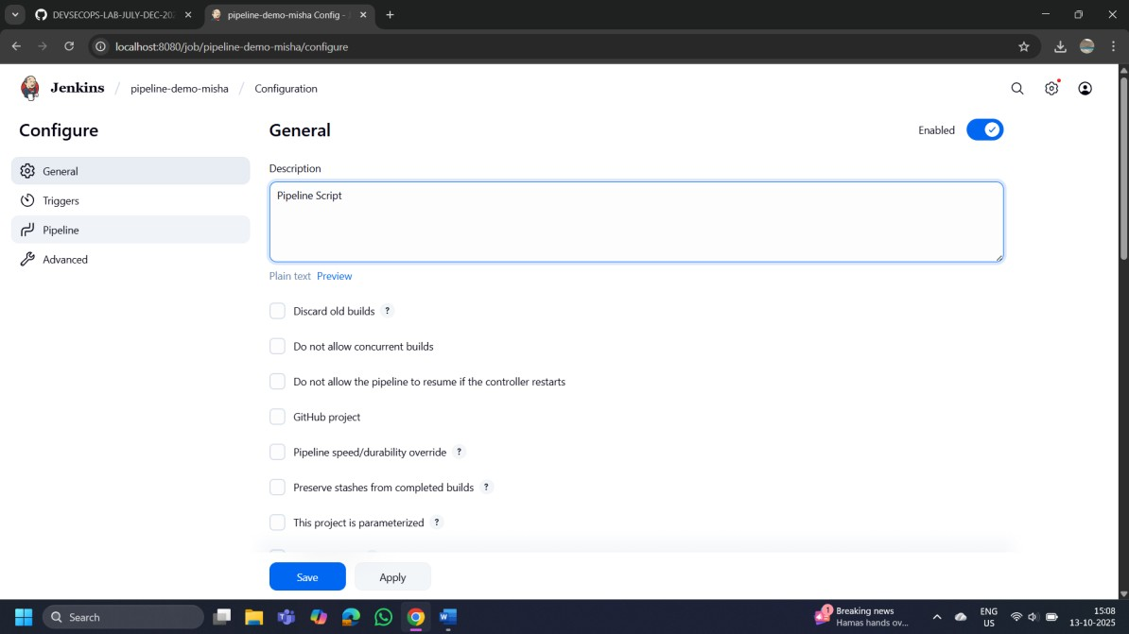
Enter the following pipeline script in the script editor and click on Save as shown in the screenshot below:
pipeline { agent any stages { stage("hello") {
steps{
echo"welcome to Jenkins pipeline"
}
}
}
}

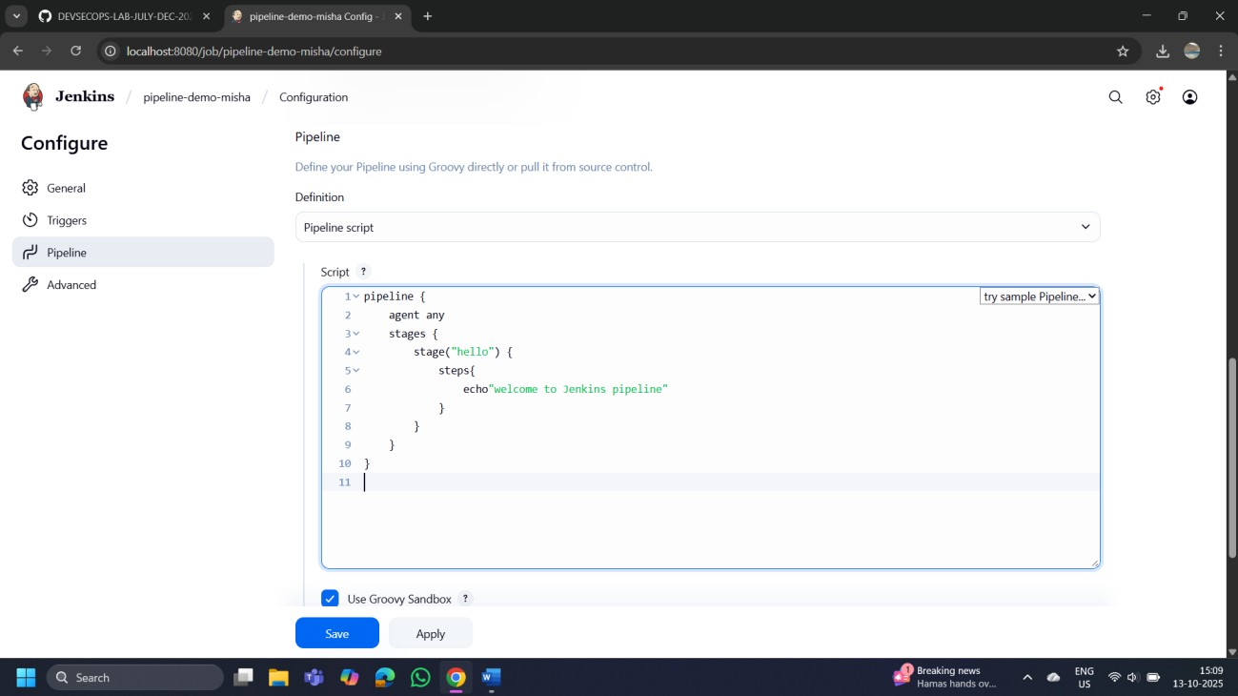

Click on Build Now to run the pipeline script as shown in the screenshot below:

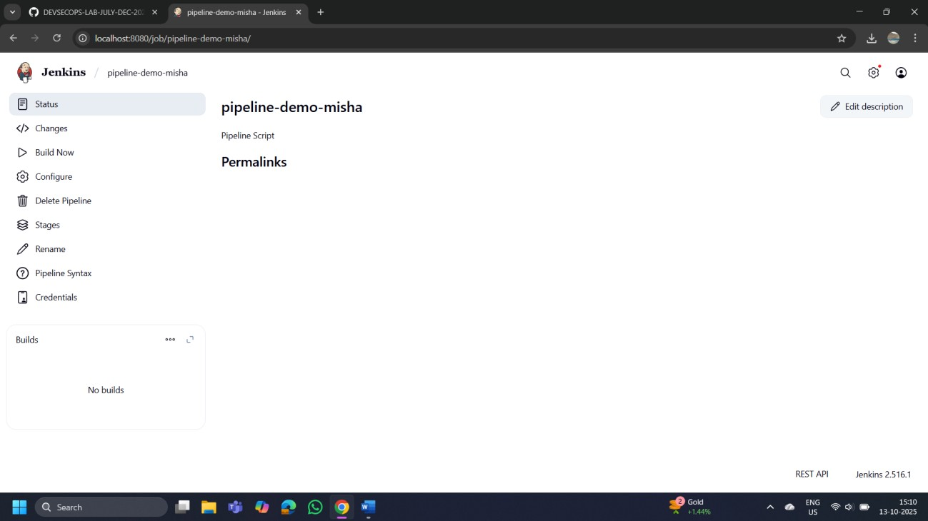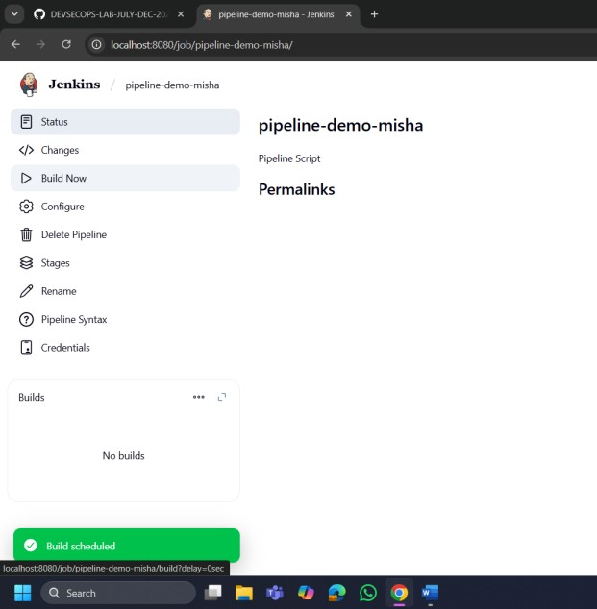

Hover over the milliseconds number next to the build stage name as shown in the screenshot below:

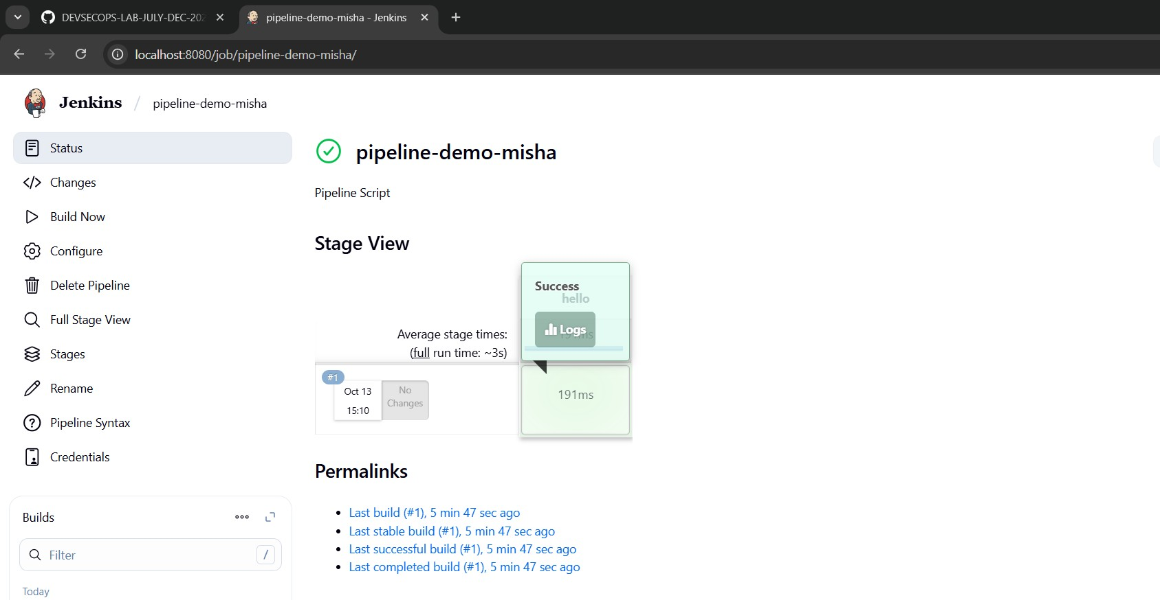

1.8 Click on Logs as shown in the screenshot below:

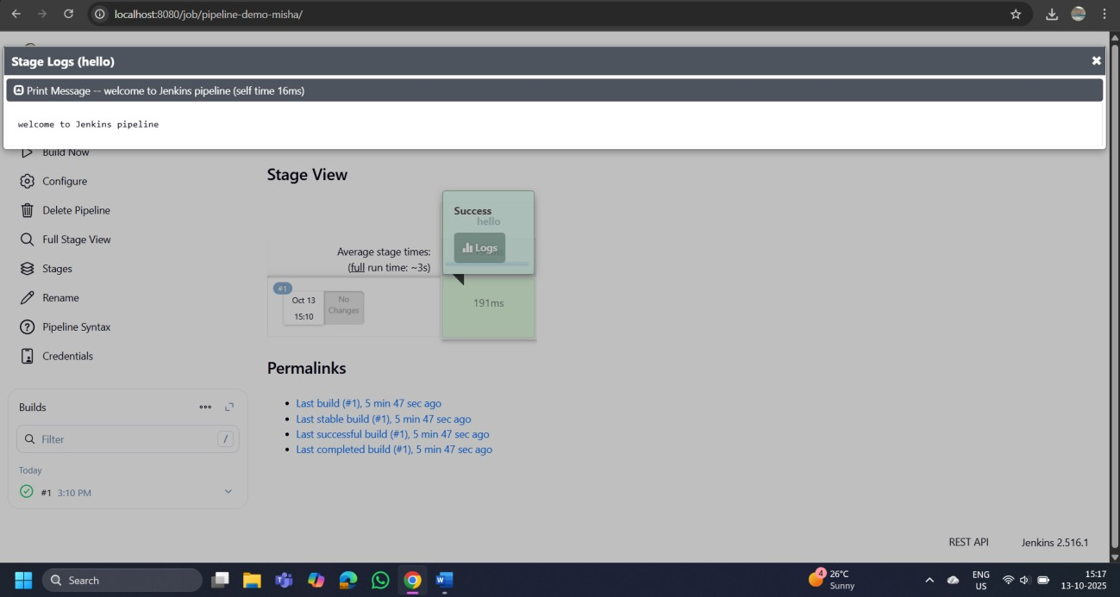

1.9 Check for the message in the top-left corner to confirm the successful execution of the pipeline stage as shown in the screenshot below:

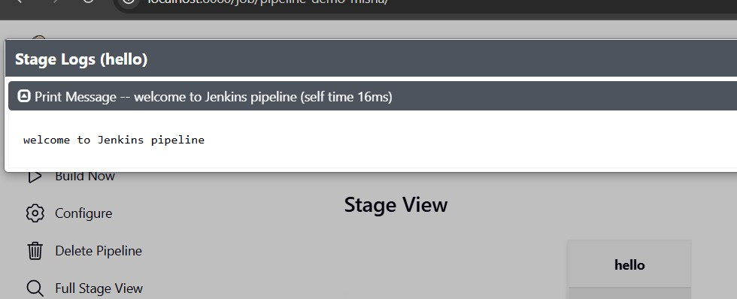

By following these steps, you have successfully created a pipeline script for automating build processes in Jenkins.

